2026 Safety Manual

Charter # 232-05-04

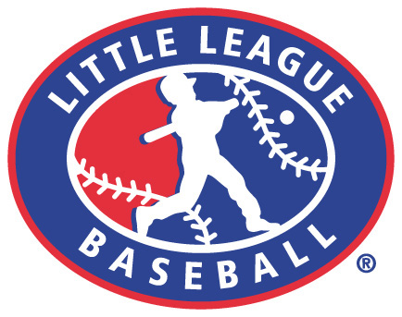
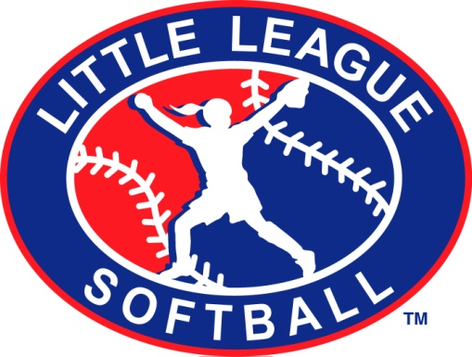

Jordan-Elbridge
Port Byron
Weedsport

Policy Statement 3
Northern Cayuga Little League Code of Conduct 3
Safety Manual 3
Facility Survey 3
Volunteer Application 3
Required First-Aid Training for Coaches/Managers/Umpires 3
Required Fundamentals Training for Coaches/Managers/Umpires 3
First-Aid Kits 4
Safety Officer 4
Community Safety Officers 4
Communicable Disease Procedures 4
Accident Reporting - Tracking Procedure 4
Emergency Phone Numbers 5
ADDITIONAL NCLL SAFETY CODE 6
Player Safety 6
Eye Injuries 8
Heat Illness: What You Need to Know 9
Don‘t Treat Heat Illness Lightly 9
Coaches Corner 14
Fundamentals Training for All Coaches and Managers 14
Why Teach the Teachers? 14
Kids: Not Just Small Adults 15
Dealing with a LOUD Parent 16

Policy Statement
The Northern Cayuga Little League (NCLL) is a non-profit organization run by volunteers whose mission is to provide an opportunity for our community’s children to learn the game of baseball and softball in a safe and friendly environment. Our safety mission is to gather our children to teach them lifelong values of teamwork and sportsmanship. We will learn to win with humility and lose without shame. We will respect and admire each other’s abilities and polish areas of weakness. We will play baseball and softball safely and stay healthy. WE WILL HAVE FUN!!!

Northern Cayuga Little League Code of Conduct
The board of directors of the Northern Cayuga Little League has mandated the following Code of Conduct. All board members, coaches and managers will read and follow this Code of Conduct.

No Board Member, Manager, Coach, Player, or Spectator shall:
- At any time, lay a hand upon, push, shove, strike, or threaten to strike an official.
- Be guilty of personal verbal or physical abuse upon any official for any real or imaginary belief of a wrong decision or judgment.
- Be guilty of an objectionable demonstration of dissent at an official’s decision by throwing of gloves, helmets, hats, bats, balls, or any other forceful unsportsmanlike actions.
- Be guilty of using unnecessarily rough tactics in the play of a game against the body of an opposing player.
- Be guilty of a physical attack upon any board member, official manager, coach, player or spectator.
- Be guilty of the use of profane, obscene, or vulgar language in any manner at any time.
- Appear on the field of play, stands, or anywhere in a NCLL complex while in an intoxicated state at any time. Intoxicated will be defined as an odor or behavior issue. No alcohol is allowed in any parking lot, field, or common area within an NCLL complex.
- Be guilty of gambling upon any play or outcome of any game with anyone at any time.
- No smoking is allowed at Little League facilities.
- Be guilty of discussing publicly with spectators in a derogatory or abusive manner any play, decision, or personal opinion on any players during the game.
- As a manager or coach, be guilty of mingling with or fraternizing with spectators during the course of the game.
- Speak disrespectfully to any manager, coach, official or representative of the league.
- Be guilty of tampering or manipulation of any league rosters, schedules, draft positions or selections, official score books, rankings, financial records or procedures.
- Shall not challenge an umpire’s authority. The umpires shall have the authority and discretion during a game to penalize the offender according to the infraction up to and including removal from the game.

Failure to comply with the above may result in expulsion from the Northern Cayuga Little League field or complex.

Safety Manual
- The intent is to print and distribute the safety plan to all staff: Concession workers, facilities crew, managers and coaches, etc. and to keep copies in common areas for all volunteers.
- The Safety Manual is required to be updated and distributed each year before the season begins. Target date: March 1st each year.
- Enforce rules at practices as well as games. Use of this safety manual is required by all Northern Cayuga Little League teams. If an issue arises that is not covered in this manual, please notify the safety officer.

Facility Survey
- Each community is required to provide the Safety Officer with a facility survey on all fields to be used in the upcoming year. Surveys should be turned in no later than April 1st.

Volunteer Application
- Managers, coaches, board members and any other persons, volunteers or hired workers, who provide regular services to the league and/or have repetitive access to or contact with players or teams must fill out the Volunteer Application form as well as provide a government-issued photo identification card for ID verification.
- The Safety Manager will conduct a search of appropriate governmental entity of the statewide sex offender registry, using Volunteer Applications, on all applicable volunteers.
- The Safety Manager may conduct a nationwide background check using resources such as LexisNexis.
- Anyone refusing to fill out a Volunteer Application is ineligible to be a league member.
- The league president must retain these confidential forms for the year of service.
- A blank copy of the league’s application form is available online at www.ncllbaseball.com.

Required First-Aid Training for Coaches/Managers/Umpires
- A date and location will be provided for ALL coaches and managers for First-Aid Training. A minimum of one participant per team is required to attend.
- This year’s training is scheduled for March 24. 2024 at Sennet Fire Department.
- The intent is to provide training to ALL coaches and managers.

Required Fundamentals Training for Coaches/Managers/Umpires
- A date and location will be provided for ALL coaches and managers for Fundamentals Training. A minimum of one participant per team is required to attend.
- This year’s training is scheduled for March 24th @ Sennett Fire Department.
- The intent is to provide training to ALL coaches and managers

First-Aid Kits
- First-aid kits are required at each game and practice.
- Each team is required to have a first aid kit for all home and away games.
- Included in your kit, you should have emergency phone numbers, supplies, and a manual to guide you through the following situations:

- Assessing the situation  - Step-by-step wound care method  - Bleeding  - Breathing problems  - Broken bone  - Bumps and scalds  - Sunburn, Heat exhaustion, Sunstroke  Choking, airway obstruction  - Poisoning | - Shock  - Splinters  - Sprains  - Stings  - Transporting an injured person  - Unconsciousness  - Wounds  - Penetrating objects

AED Machines
- AED machines are required at each game and practice.
- Will be located at the snack shacks and storage room at field locations.
- Coaches will be trained to use the machines CPR/AED training for 2 people on the team.
- Machines will be maintained regularly.

Safety Officer
The Northern Cayuga Little League Safety Officer’s Responsibilities are:

Within 48 hours of receiving the incident report, the Safety Officer should contact the injured party or the party’s parents and:

- Verify the information received.
- Obtain any other information deemed necessary.
- Check on the status of the injured party.
- In the event that the injured party requires other medical treatment (i.e., Emergency Room visit, doctor’s visit, etc.), will advise the parent or guardian of the Northern Cayuga Little League’s insurance coverage and the provisions for submitting any claims.
Note: Parent or guardian’s insurance is the primary coverage, and Northern Cayuga Little League is secondary.

If the extent of the injury is more than minor in nature, the Safety Officer shall periodically call the injured party to:

- Check on the status of the injuries.
- To check if any other assistance is necessary in areas such as submission of insurance forms, etc. until such time as the incident is considered “closed” (i.e., no further claims are expected and/or the individual is participating in the league again).

Northern Cayuga Little League Safety Officers for the upcoming Season:
Tiffany Whittaker
315-730-9396
Ncllbaseball123@gmail.com

Communicable Disease Procedures
  - Bleeding must be stopped, the open wound covered, and the uniform changed if there is blood on it before the athlete may continue.
  - Routinely use gloves to prevent membrane exposure when contact with blood or other body fluids are anticipated (provided in first aid kit).
  - Immediately wash hands and other skin surfaces if contaminated with blood
  - Clean all blood-contaminated surfaces and equipment.
  - Managers, coaches, and volunteers with open wounds should refrain from all contact until the condition is resolved.
  - Follow accepted guidelines in the immediate control of bleeding and disposal when handling bloody dressings, mouthguards, and other articles containing body fluids.

Accident Reporting - Tracking Procedure
- Injuries and accidents must be submitted in writing and mailed or emailed to the safety officer’s home within 24 hours of the time of the incident. You should also call the Safety Officer on the same day of the incident. This includes, but is not limited to, injuries to players, managers, coaches, umpires, spectators, or anyone else injured within the Little League complex.
- Northern Cayuga County Little League will use the ASAP Incident/Injuring Tracking Report form, which is located at the back of this manual. This form should be completed by the manager, coach, or designated team parent. Additional forms can be obtained by contacting the Safety Officer. Don’t forget to re-supply your first aid needs at the same time.
- Injuries requiring medical care outside of what is provided by the first aid kit must, in addition to the forms, speak with the safety officer within 24-48 hours from the time of injury. Failure to do so may result in charges against the league.
What to Report
- Track “near-misses” as a proactive tool to evaluate practices and avoid potential future accidents and injuries. Information on accidents and “near-misses” will be shared with district to find way to prevent accidents.
- There is no need to report any minor ‘bumps and scrapes” requiring just a simple band aid.
- Report any injury requiring an ice bag, bee sting, heat related illnesses, eye injuries (including dirt in the eye requiring washing), calls requiring park security and or the Sheriff’s Department, any need for out-of-the-park health care, notice of medical care after the game or practice in which initial evaluation was believed care was not needed, or any other injury worthy of what deems necessitating awareness (i.e. a bicycle injury going to or while going home from, the game or practice).
- Track the use of the AED machine with the safety officer.

Defining Terms
To clarify the meaning of these guidelines, we are defining the use of the terms essential to an understanding of a basic accident-prevention program in Little League Baseball. They are as follows:

- An ACCIDENT is a sudden, undesirable, and unplanned occurrence often resulting in bodily injury, disability, and/or property damage.
- An ACCIDENT CAUSE is an unsafe condition, situation, or act that may result directly in/or contribute to the occurrence of an accident.
- CORRECTIVE ACTION is the positive steps or measures taken to eliminate, or at least minimize, an accident cause.
- CASE is used in the general sense, such as: accident case, injury case, claim case, or insurance case.
- HAZARD refers to a condition or a situation that could cause an accident.
- INJURY is the physical harm or damage often resulting from an accident.
- INSURANCE CLAIM refers to the right of a parent, as in the case of accident insurance, to have eligible medical expenses resulting from an accidental injury connected with a game or scheduled practice paid by the appropriate insurance company;
- TYPE OF ACCIDENT is a phrase used to describe an unintentional, sudden incident that can be identified so effective counter measures may be taken. Examples are: struck by, tripped, fell, collision with, caught between, etc.
- AN UNSAFE ACT refers to unintentional human failure or lack of skill that can lead to an accident. It is one of the two general accident causes, the other being an unsafe condition.
- AN UNSAFE CONDITION is an abnormal or faulty situation or condition that may cause an accident. Its presence, particularly when an unsafe act is committed, may result in an accident.

The administration of an effective safety program is the responsibility of all who operate the Little League system on all levels. The inexperience and dependence of young children on adult guidance make it imperative that all levels of authority make safety an integral part of their behavior, transaction of league affairs, and instructions to the players.

Emergency Phone Numbers
Ambulance 911
Fire Department 911
Police Department 911

LITTLE LEAGUE SAFETY CODE (From Little League Rule Book)
- Responsibility for safety procedures should be that of an adult member of NCLL.
- Arrangements should be made in advance of all games and practices for emergency medical services.
- Managers, coaches and umpires should have some training in first-aid, First-Aid Kit should be available at the field.
- Field inspections to be performed by coaches, managers and umpires prior to game commencement
- No games or practice should be held when weather or field conditions are not good, particularly when lighting is inadequate.
- Play area should be inspected frequently for holes, damage, glass and other foreign objects.
- Dugouts and team equipment should be positioned behind screens.
- Only players, managers, coaches and umpires are permitted on the playing field during play and practice sessions.
- Responsibility for keeping bats and loose equipment off the field of play should be that of a regular player assigned for this purpose.
- Procedure should be established for retrieving foul balls batted out of the playing area.
- During practice sessions and games, all players should be alert and watching the batter on each pitch.
- During warm up drills, players should be spaced so that no one is endangered by errant balls.
- Equipment should be inspected regularly. Make sure it fits properly.
- Pitching machines, if used, must be in good working order (including extension cords, outlets, etc.) and must be operated only by adult managers and coaches.
- Batters must wear protective NOCSAE helmets during practice, as well as during games.
- Catchers must wear catcher's helmet (with face mask and throat guard), chest protector and shin guards. Male catchers must wear long-model chest protector (divisions
below Junior/Senior/Big League), protective supporter and cup at all times.
- Except when runner is returning to a base, head first slides are not permitted. This rule applies to Little League Majors, Minor, Pony and Instructional League.
- During sliding practice bases should not be strapped down.
- At no time should "horse play" be permitted on the playing field.
- Parents of players who wear glasses should be encouraged to provide "Safety Glasses."
- Players must not wear watches, rings, pins, jewelry or other metallic items.
- Catchers must wear catcher's helmet, face mask and throat guard in warming up pitchers. This applies between innings and in bull pen practice. Skull caps are not permitted.
- Batting/catcher's helmets should not be painted unless approved by the manufacturer.
- Regulations prohibit on-deck batters. This means no player should handle a bat, even while in an enclosure, until it is his/her time at bat. This rule applies to Little League
Majors, Minor, Pony and Instructional League.
- Players who are ejected, ill or injured should remain under supervision until released to the parent or guardian.

ADDITIONAL NCLL SAFETY CODE
- In the event of Thunder or Lightning, all games played on Monday through Friday will be immediately postponed for that evening. If the game has not met the guidelines for a complete game, then the game should be rescheduled on a new date from the point it was postponed. Note that this will generally be at a later date. If deemed a complete game, the game score should be turned in.
- In the event of Thunder or Lightning, all games played on Saturday or Sunday will be immediately postponed. All ballplayers, coaches, and fans should move to a safe place, i.e., a car, snack shack, or building. If the game can be continued within 60 minutes, it should be continued. If play cannot be continued and the guidelines for a complete game have not been met, then the game should be rescheduled on a new date from the point it was postponed. Note that this will generally be at a later date. Otherwise, the game score should be turned in and considered a complete game. Note that play cannot resume until 30 minutes after the cessation of either thunder or lightning.
- Note: A normal season game uses Little League’s guidelines for a complete game. All playoff games use NCLL guidelines for a complete game, which state that the game must be played to completion.
- All pre-game warm-ups should be performed within the confines of the playing field and not within areas that are frequented by, and thus endangering spectators, (i.e., playing catch, pepper, swinging bats, etc.)
- Managers will only use the official Little League balls supplied by NCLL.
- Once a ball has become discolored, it will be discarded.
- Female catchers must wear long or short model chest protectors.
- Catchers (in Baseball Only) must wear a catcher’s mitt (not a first baseman’s mitt or fielder’s glove) of any size or weight consistent with protecting the hand.
- Shoes with metal spikes or cleats are not permitted. Shoes with molded cleats are permissible.
- Players will not wear watches, rings, pins, jewelry, or other metallic items during practices or games. (Exception: Jewelry that alerts medical personnel to a specific condition is permissible, and this must be taped in place.)
- No food or drink, at any time, in the dugouts. (Exception: bottled water, Gatorade, and water from drinking fountains)
- Managers will never leave an unattended child at a practice or game.
- Never hesitate to report any present or potential safety hazard to the NCLL Safety Officer immediately.
- Make arrangements to have a cellular phone available when a game or practice is at a facility that does not have public phones.
- No alcohol, drugs, or smoking are allowed on the premises at any time.
- No medication will be taken at the facility unless administered directly by the child’s parent. This includes aspirin and Tylenol.
- No swinging bats or throwing baseballs at any time within the walkways and common areas of the complex.
- No climbing fences, no swinging on dugout roofs.
- No one is allowed on the field with open wounds at any time. Wounds should be treated and properly bandaged.
- There is no running allowed in the bleachers.
- No throwing balls against dugouts or backstops.
- During games, players must remain in the dugout area in an orderly fashion at all times.

Failure to comply with the above may result in expulsion from the Northern Cayuga Little League field or complex.

Player Safety

Field Inspections
- Umpires and the coaches of both teams are required to walk the field for common sense hazards — look for rocks, glass, holes, etc.

Regular Inspection and Replacement of Equipment is required
- Coaches and umpires are required to inspect equipment before each use.
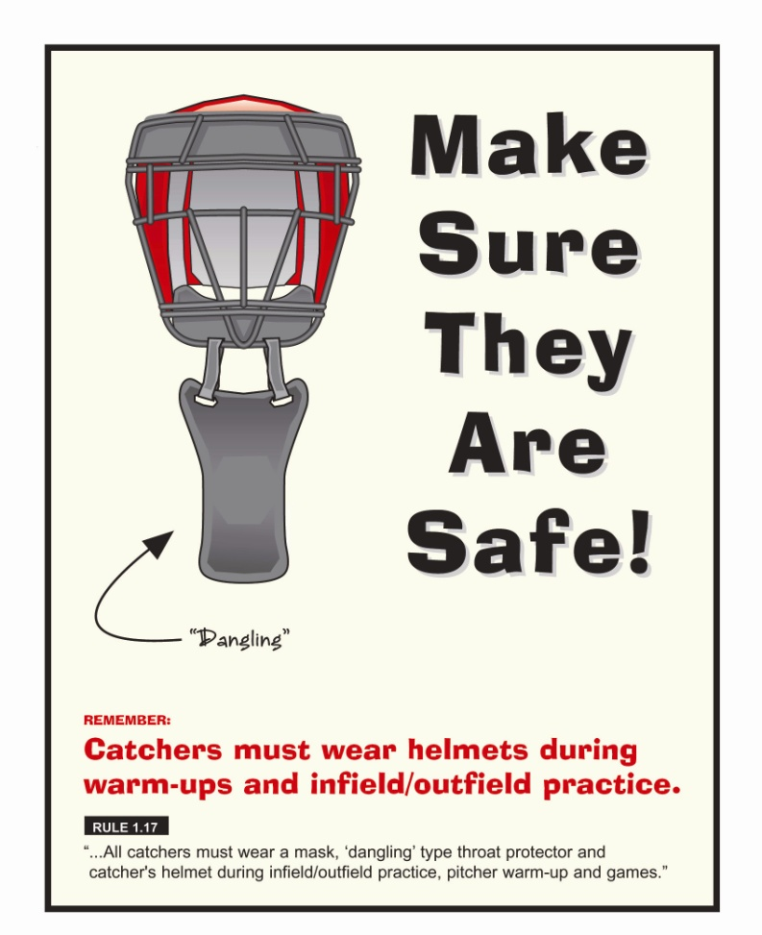
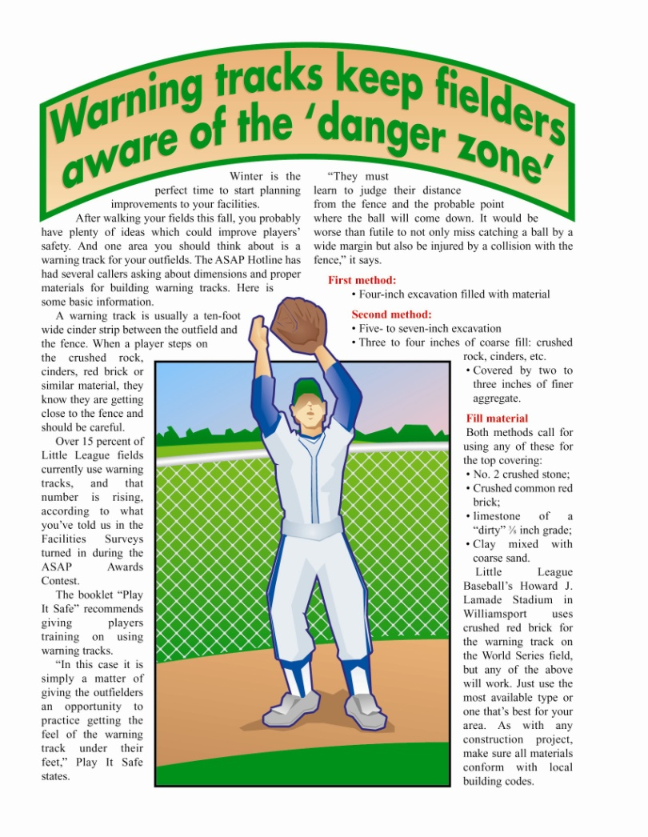
- Don’t just discard bad equipment; destroy it or make it unusable to stop children from attempting to “save it” from waste. 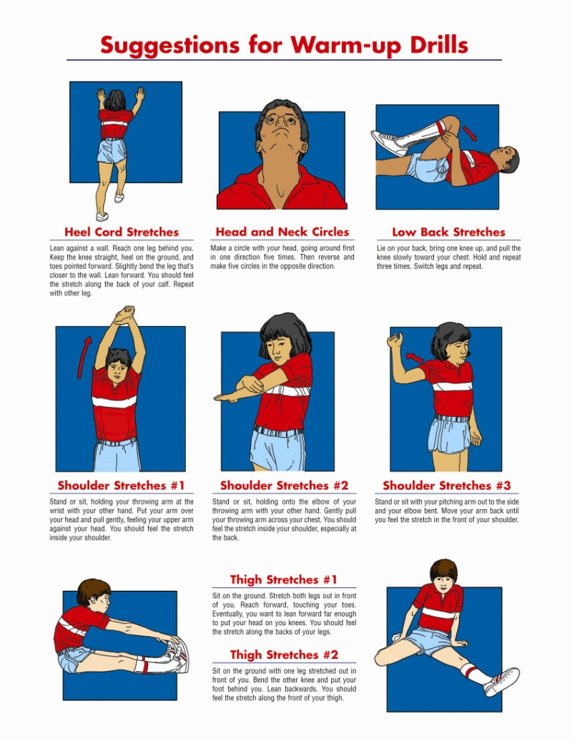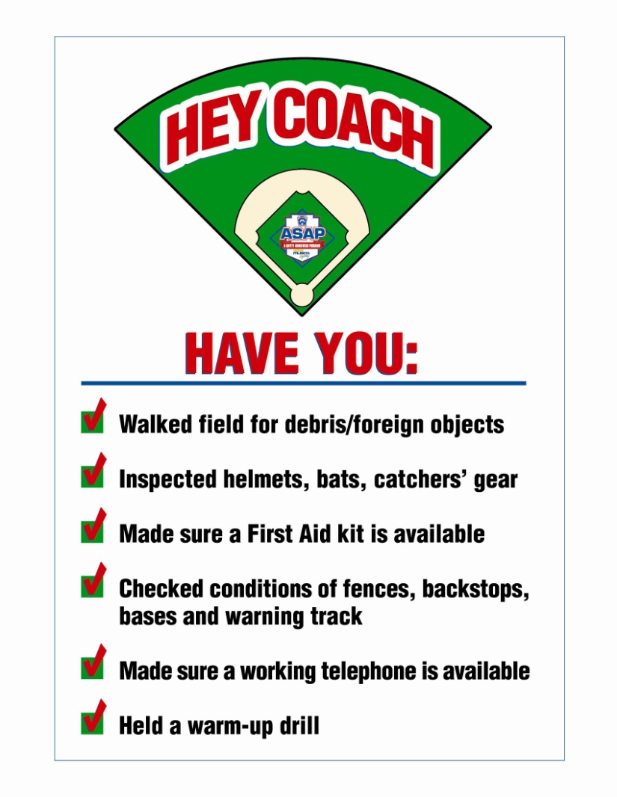
General Safety

Eye Injuries
- You can treat many minor eye irritations by flushing the eye, but more serious injuries require medical attention. Injuries to the eye are the most common preventable cause of blindness; so when in doubt, err on the side of caution and call for help.

Routine Irritations (sand, dirt, and other "foreign bodies" on the eye surface)
- Do not try to remove any “foreign body” except by flushing.
- Wash your hands thoroughly before touching the eyelids to examine or flush the eye.
- Do not touch, press, or rub the eye, and do whatever you can to keep the child from touching it.
- Tilt the child’s head over a basin with the affected eye down and gently pull down the lower lid, encouraging the child to open her eyes as wide as possible.
- Gently pour a steady stream of lukewarm water from a pitcher across the eye.
- Flush for up to fifteen minutes, checking the eye every five minutes to see if the foreign body has been flushed out.
- Since a particle can scratch the cornea and cause an infection, the eye should be examined by a doctor if there continues to be any irritation afterwards.
- If a foreign body is not dislodged by flushing, it will probably be necessary for a trained medical practitioner to flush the eye.

Embedded Foreign Body (an object penetrates the globe of the eye)
- Call for emergency medical help.
- Cover both eyes (the unaffected eye must be covered to prevent movement of the affected eye). If the object is small, use eye patches or sterile dressing for both. If the object is large, cover the injured eye with a small cup taped in place and the other eye with an eye patch or sterile dressing. The point is to keep all pressure off the globe of the eye.
- Keep your child (and yourself) as calm and comfortable as possible until help arrives.
- A black eye is often a minor injury, but it can also appear when there is significant eye injury or head trauma. A visit to your doctor or an eye specialist may be required to rule out serious injury, particularly if you’re not certain of the cause of the black eye.
For a “simple” black eye:
- Apply cold compresses intermittently: five minutes to 10 minutes on, 10 minutes to 15 minutes off. If you are not at home when the injury occurs and there is no ice available, a cold soda will do to start. If you use ice, make sure it is covered with a towel or sock to protect the delicate skin on the eyelid.
- Use cold compresses for 24 to 48 hours, then switch to applying warm compresses intermittently. This will help the body reabsorb the leakage of blood and may help reduce discoloration.
- If the child is in pain, give acetaminophen – not aspirin or ibuprofen, which can increase bleeding.
- Prop the child’s head with an extra pillow at night, and encourage her to sleep on the uninjured side of her face (pressure can increase swelling).
- Call your doctor, who may recommend an in-depth evaluation to rule out damage to the eye. Call immediately if any of the following symptoms appear:
  - increased redness
  - drainage from the eye
  - persistent eye pain
  - distorted vision
  - any visible abnormality of the eyeball
- If the injury occurred during one of your child’s routine activities such as a sport, follow up by investing in an ounce of prevention – protective goggles or unbreakable glasses are vitally important.

Tips to Help Prevent Sports-Related Eye Injuries
- Parents must insist their children wear appropriate eye protection during sports activities.
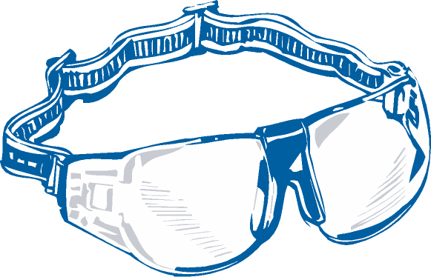
- Adults and children participating in baseball or softball, considered high-risk sports for eye injuries by the American Association of Ophthalmology, should always wear appropriate sport-specific protective eyewear. Leagues should encourage eye protection.
- Protective eyewear lenses should be made of polycarbonate material, a material ten times more impact-resistant than other plastics and can withstand the force of a .22 caliber bullet. Polycarbonate material offers the best protection against many sports-related eye injuries.
- Do not wear contact lenses, ordinary street wear glasses or industrial safety eyewear as a substitute for protective eyewear. Contact lenses, ordinary glasses and industrial safety eyewear offer no protection against eye injuries.
- Make sure your sports protective eyewear fits properly. Your eyewear can be properly fitted by your Eye MD (ophthalmologist).
- Wear sports protective eyewear every time you play! Please make sure your kids do, too.
- In baseball, wear a helmet with a polycarbonate facemask or wire shield. Make sure baseball facemasks are approved by the National Operating Committee on Standards for Athletic Equipment (NOCSAE).
- If you do sustain an eye injury, don’t try to treat it yourself. Go to your local emergency room or call your ophthalmologist immediately!

Heat Illness: What You Need to Know

Don‘t Treat Heat Illness Lightly
- Most coaches understand they need to take breaks between innings of games when the temperatures soar, giving their players a chance to re-hydrate and dissipate their extra body heat. But be careful with practices, too.
- High school, college, and professional athletes have died of heat illness in the last several years during practices in hot, humid weather. Cory Stringer of the Minnesota Vikings NFL team is the most famous case, but the combination of high heat and humidity can create an atmosphere where the athletes’ bodies cannot properly dissipate the heat they generate in even normal activities.
- Take breaks every 20 minutes for water and rest in the shade or with cool, wet clothes to drape over necks and promote evaporation to help the skin cool the body’s interior.
- Bring a cooler with ice and water for players to use throughout practice and games. In severely hot areas like southern California, Arizona, and New Mexico, leagues have set up misters in the dugouts to spray a light water mist over the players to help cool them each inning.
- Children’s heat-regulating processes are not fully developed, and their skin surface is proportionately greater than that of an adult’s. So don't expose players to prolonged workouts or games in high heat or moderate heat with high humidity; it’s a risk you shouldn’t take.
- Because their body surface to weight ratio is high, a child’s skin works against them, taking in more heat than they can absorb internally; so where an adult’s temperature might slowly climb as they become overheated, on a hot, humid day a child’s will skyrocket, leaving little time to react.
- Umpires need special attention, too, since they, like the catcher, wear extra protection that can keep their body’s heat from being evaporated. But unlike catchers, the plate umpire doesn’t take off the equipment. So make sure umpires drink plenty of water and take breaks for 10-15 minutes every couple of innings, especially on hot days. A game’s playing time is less important than a person’s health, and heat injury can cause prolonged susceptibility to heat.
- The young and old are especially susceptible to heat illness, as are people who work or exercise strenuously outside for long periods during the day are also at increased risk for heat-related illness. This combination for young athletes demands that coaches be vigilant.
- Lock your car doors even when you’re home. Cars can be tempting places for young children to play, whether at the ball diamond or at home. A three-year-old died last year in Dallas, Texas, when he was trapped in an SUV for just 20 minutes while playing with other children. The outside temperatures reached 100 degrees, but the inside of the vehicle was estimated at 150 degrees.
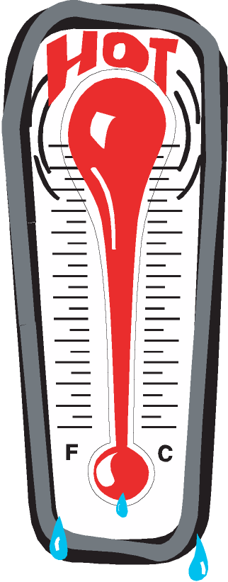
- People with health concerns, known or not, are also at higher risk, making children with health conditions doubly susceptible:
When to Play
- With All-Star games nearly upon us, make sure coaches aren’t over-scheduling practices. Practice should occur in the morning before noon or in the evening as temperatures start to drop.
- On hot days, many leagues have a mandatory break every three innings for all participants — especially needed for umpires, catchers, and pitchers — to cool off and re-hydrate. On especially hot days, take a break more often.
What and When to Drink
- Drink 10 to 16 ounces of cold fluid about 15 to 30 minutes before workouts.
- Drink 4 to 8 ounces of cold fluid during exercise at 10 to 15 minute intervals.
- Drink a beverage that contains a small amount of sodium and electrolytes like potassium and chloride.
- Start drinking early in your workout because you will not feel thirsty until you have already lost two percent of your body weight; by that time you will already be significantly dehydrated.
- Avoid carbonated drinks, which can cause gastrointestinal distress and may decrease the fluid volume.
- Avoid beverages with caffeine due to its diuretic effect.
- Research has found that sports drinks containing between 6% and 8% carbohydrate (sugars) are absorbed into the body as rapidly as water and can provide energy to working muscles that water cannot.
Beat Heat Illness: Prevent Heat Injuries through Preparation
As the temperature and humidity rise, so do the risks of heat illness. July and August are the worst months for heat illness for athletes. Heat stress is the first stage of heat illness, with warning signs of thirst, fatigue, and feeling overheated. If these signs are ignored, heat illness may develop.
To protect players from heat illnesses — heat cramps, heat stroke, heat stress, heat exhaustion and heat stroke — they can occur separately or in combination. Make sure all your players are properly hydrated before games and practices.

Heat cramps are severe pain and cramps in the legs and abdomen, faintness or dizziness, weakness, and profuse sweating. This condition requires immediate medical attention but is usually not life-threatening. Heat cramps usually occur after strenuous exercise or an outdoor activity. Tend to attack the muscles that do the hardest work, especially when it is hot. A good rule is to drink half a glass of water every 15 minutes for an hour if you experience heat cramps.

Fainting: Lets you know your body is having difficulty coping with the heat. As you know, when you faint, you fall, and when you are on the field and fall, you can get hurt or hurt others. Prickly Heat: A rash caused when sweat can’t evaporate. Sweat ducts become clogged, and sweat glands become inflamed.

Heat stroke, which is a serious medical condition often resulting in death, occurs when the body is unable to manage its heat load and fails to cool itself. The skin may be hot but dry, and the victim may be unconscious, delirious, or having seizures. For athletes, the onset of heat stroke may be so swift that the person is still sweating.
Heat Stress: What is heat stress? Take a hot job, add a hot day, and high humidity, and it can add up to heat stress! This condition occurs when the body is unable to regulate its temperature. This is the body’s way of saying, “I can’t take the heat anymore.” The early warning signs of heat stress include thirst, fatigue, and feeling hot. If these signs are ignored, serious heat illness beginning with cramps and progressing to heat exhaustion and heat stroke can develop.
Ways to Avoid Heat Stress:
Acclimatize: This means allowing your body to adjust to the heat naturally. The best way to do this is to gradually increase the time you spend in the heat until you reach the total amount of time desired.
Drink Water! One of the most important things to do is drink plenty of water during hot weather. The body can lose as much as three gallons of fluid a day while working in hot, humid weather. Drink some cool water every 15-20 minutes.
Use Salt: Add salt to your food, but don’t overdo it, such as taking salt tablets. If you have high blood pressure, heart problems, or circulatory ailments, consult your doctor.
Eat Lightly: Light, nutritious meals, preferably cold, are better for you because they are easier to digest. Fatty foods are hard to digest, and hot weather makes them that much harder to digest.
“With the heat approaching in some areas and already there in other areas, here is something to be alert for. Not only should you keep an eye on the players during a game, but also the umpires. Hopefully, we will not have any problems as long as we follow the advice below.”
Heat exhaustion happens when one is exposed to heat for a prolonged period. The body may become overwhelmed by heat when the sweat mechanism, which keeps the body cool, breaks down. Symptoms of heat exhaustion include nausea, dizziness, weakness, headache, pale and moist skin, weak pulse or rapid heartbeat, and disorientation.
Symptoms:  - Sweating profusely  - Weakness  - Clammy skin  - Dizziness  - Pale or flushed face  - Nausea  - Near normal body temperature | First Aid:  - Move the person to shade or a cool place.  - Have the patient lie on their back with feet elevated.  - If conscious, give half a glass of water every 15 minutes.  - Get medical help.
Heat Stroke is a medical emergency! Heatstroke occurs when the body’s heat regulating system breaks down under stress and sweating stops. Unless the victim receives quick treatment, death can occur.
Symptoms:  - No sweating (or the victim may be sweating profusely)  - High body temperature (105 or more)  - Hot, dry, flushed skin  - Confused, delirious behavior  - Loss of consciousness or coma | First Aid:  - Immediately call for medical help and then start first aid  - Move the victim to a cool place  - Cool the victim quickly by giving a cool bath (sponging with cool water) and by fanning  - Treat for shock  - Offer a conscious person half a glass of water every 15 minutes

Hot Weather Tips
Safety Concerns:
There are other problems with heat that you may not realize until it is too late. Heat stress can alter your coordination, lessen your concentration, reduce strength and alertness, and make you irritable.
Heat stroke, unlike heat exhaustion, strikes suddenly and with little warning. When the body’s cooling system fails, the body’s temperature rises quickly. Heat stroke can be life-threatening and requires immediate medical attention!
Symptoms of heat stroke include very high body temperature, hot, dry skin, lack of sweating, fast pulse, confusion, and possible loss of consciousness.
NOTE: For athletes, often the skin never stops sweating, even when entering heat stroke. It is necessary to evaluate the person’s mental state for signs of confusion, disorientation, or coma. If any of these are present, immediately contact medical help and begin cooling through cold water immersion or application, or by cold wet clothes application.
Tips to Prevent Heat Illness
- Know that once you are thirsty, you are already dehydrated. Drink continuously, even before you are thirsty.
- Do not exercise vigorously during the hottest time of day. Try to train closer to sunrise or sunset.
- Wear lightweight, light colored, loose clothing, such as cotton, so sweat can evaporate.
- Use sunscreen to prevent sunburn, which can hinder the skin's ability to cool itself.
- Wear a hat that provides shade and allows ventilation.
- Drink plenty of liquids, such as water or sports drinks, every 15 minutes (drink 16-20 oz/hour).
- If you feel your abilities start to diminish, stop the activity and try to cool off. Sit in the shade, air-conditioned car or use ice bags or cold water to lower the body’s temperature.
- Do not drink beverages with caffeine before or during exercise because they increase the rate of dehydration.
- Remember, it is easier to prevent heat illness than to treat it once symptoms develop.

Lightning Kills...
A thunderstorm is approaching or nearby. Are conditions safe, or is it time to head for safety? Not wanting to appear overly cautious, many people wait far too long before reacting to this potentially deadly weather threat.
To promote a better understanding of the threats of lightning, the National Weather Service and the National Oceanic and Atmospheric Administration (NOAA), in conjunction with lightning experts across the country, are sponsoring Lightning Safety Awareness Week from April 28 to May 4, 2002. The goal of this campaign is to give people a better understanding of the dangers of lightning so they can make safer decisions when thunderstorms threaten. The safety recommendations outlined during the week are based on lightning research and the lessons learned from the unfortunate experiences of thousands of lightning strike victims.
Thunderstorms produce two types of lightning flashes, ‘negative’ and ‘positive.’ While both types are deadly, the characteristics of the two are quite different. Negative flashes occur more frequently, usually under or near the base of the thunderstorm where rain is falling. In contrast, positive flashes generally occur away from the center of the storm, often in areas where rain is not falling. Because these positive flashes occur where the lightning threat is perceived as low or nonexistent, they often catch people by surprise. Each year across the United States, thunderstorms produce an estimated 25 million cloud-to-ground flashes of lightning — each one of those flashes is a potential killer. According to the National Weather Service, an average of 73 people are killed by lightning each year, and hundreds more are injured, some suffering devastating neurological injuries that persist for the rest of their lives. A growing percentage of those struck are involved in outside recreational activities.

Officials responsible for sports events often lack adequate knowledge of thunderstorms and lightning to make educated decisions on when to seek safety. Without knowledge, officials base their decisions on personal experience and, sometimes, on the desire to complete the activity. Due to the nature of lightning, personal experience can be misleading. While many people routinely put their lives in jeopardy when thunderstorms are nearby, few are actually struck by lightning. This results in a false sense of safety. Unfortunately, this false sense of safety has resulted in numerous lightning deaths and injuries during the past several decades because people made decisions that unknowingly put their lives or the lives of others at risk.
For organized outdoor activities, the National Weather Service recommends that those in charge have a lightning safety plan and that they follow the plan without exception. The plan should give clear and specific safety guidelines in order to eliminate errors in judgment. Prior to an activity or event, organizers should listen to the latest forecast to determine the likelihood of thunderstorms. NOAA Weather Radio is a good source of up-to-date weather information. Once people start to arrive, the guidelines in the lightning safety plan should be followed. The information on page 5 outlines some considerations when creating a lightning safety plan.
When should activities be stopped?
The sooner activities are stopped and people get to a safe place, the greater the level of safety. In general, a significant lightning threat extends outward from the base of a thunderstorm cloud for about 6 to 10 miles. Therefore, people should move to a safe place when a thunderstorm is 6 to 10 miles away. Also, the plan’s guidelines should account for the time it will take for everyone to get to a safe place. Here are some criteria that could be used to halt activities.
1. If lightning is observed. The ability to see lightning varies depending on the time of day, weather conditions, and obstructions such as trees, mountains, etc. In clear air, and especially at night, lightning can be seen from storms more than 10 miles away, provided that obstructions don’t limit the view of the thunderstorm.
2. If thunder is heard. Thunder can usually be heard from a distance of about 10 miles, provided that there is no background noise. Traffic, wind, and precipitation may limit the ability to hear thunder less than 10 miles away. If you hear thunder, though, it’s a safe bet that the storm is within ten miles.
3. If the time between lightning and the corresponding thunder is 30 seconds or less. This would indicate that the thunderstorm is 6 miles away or less. As with the previous two criteria, obstructions, weather, noise, and other factors may limit the ability to use this criterion. In addition, a designated person must diligently monitor any lightning.
In addition to any of the above criteria, activities should be halted if the sky looks threatening. Thunderstorms can develop directly overhead, and some storms may develop lightning just as they move into an area.
Where should people go for safe shelter?
There is no place outside that is safe in or near a thunderstorm. Consequently, people need to stop what they are doing and get to a safe place immediately. Small outdoor buildings, including dugouts, rain shelters, sheds, etc., are NOT SAFE. Substantial buildings with wiring and plumbing provide the greatest amount of protection. Office buildings, schools, and homes are examples of buildings that would offer protection. Once inside, stay away from windows and doors and anything that conducts electricity, such as corded phones, wiring, plumbing, and anything connected to these. In the absence of a substantial building, a hard-topped metal vehicle with the windows closed provides good protection. Occupants should avoid contact with metal in the vehicle and, to the extent possible, move away from windows.
When should activities be resumed?
Because electrical charges can linger in clouds after a thunderstorm has passed, experts agree that people should wait at least 30 minutes after the storm before resuming activities.
Who should monitor the weather, and who is responsible for deciding to stop activities?
Lightning safety plans should specify that someone be designated to monitor the weather for lightning. The ‘lightning monitor’ should not include the coaches, umpires, or referees, as they are not able to devote the attention needed to adequately monitor conditions. The ‘lightning monitor’ must know the plan’s guidelines and be empowered to assure that those guidelines are followed.
What should be done if someone is struck by lightning?
Most lightning strike victims can survive a lightning strike; however, medical attention may be needed immediately — have someone call for medical help. Victims do not carry an electrical charge and should be attended to at once. In many cases, the victim’s heart and/or breathing may have stopped and CPR may be needed to revive them. The victim should continue to be monitored until medical help arrives; heart and/or respiratory problems could persist, or the victim could go into shock. If possible, move the victim to a safer place away from the threat of another lightning strike.
For additional information:
The National Weather Service and NOAA have set up a website that provides a wealth of information on lightning and lightning safety. The address is: www.lightningsafety.noaa.gov/

In addition, the National Collegiate Athletic Association has adopted a specific set of lightning safety recommendations used for intercollegiate athletic events. The recommendations can be found at:
www.ncaa.org/sports_sciences/sports_me d_handbook/1d.pdf
For further information concerning lightning or weather safety, contact the nearest National Weather Service Office. The nearest office can be located on the following website by clicking on the appropriate state. www.stormready.noaa.gov/contact.htm

Concessions Safety
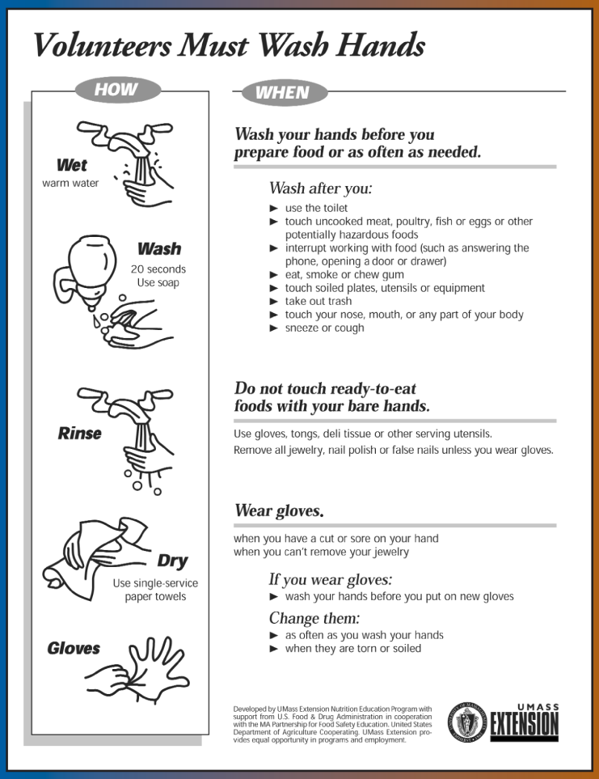
13 Steps to Safe and Sanitary Food Service Events: The following information is intended to help you run a healthful concession stand. Following these simple guidelines will help minimize the risk of foodborne illness. This information was provided by District Administrator George Glick and is excerpted from "Food Safety Hints" by the Fort Wayne-Allen County, Ind., Department of Health.
- Menu
Keep your menu simple, and keep potentially hazardous foods (meats, eggs, dairy products, protein salads, cut fruits and vegetables, etc.) to a minimum. Avoid using precooked foods or leftovers. Use only foods from approved sources, avoiding foods that have been prepared at home. Complete control over your food, from source to service, is the key to safe, sanitary food service.
- Cooking
Use a food thermometer to check on cooking and holding temperatures of potentially hazardous foods. All potentially hazardous foods should be kept at 41º F or below (if cold) or 140º F or above (if hot). Ground beef and ground pork products should be cooked to an internal temperature of 155º F, poultry parts should be cooked to 165º F. Most food borne illnesses from temporary events can be traced back to lapses in temperature control.

- Reheating.
Rapidly reheat potentially hazardous foods to 165º F. Do not attempt to heat foods in crock pots, steam tables, over sterno units, or other holding devices. Slow-cooking mechanisms may activate bacteria and never reach killing temperatures.
- Cooling and Cold Storage.
Foods that require refrigeration must be cooled to 41º F as quickly as possible and held at that temperature until ready to serve. To cool foods down quickly, use an ice water bath (60% ice to 40% water), stirring the product frequently, or place the food in shallow pans no more than 4 inches in depth and refrigerate. Pans should not be stored one atop the other and lids should be off or ajar until the food is completely cooled. Check temperature periodically to see if the food is cooling properly. Allowing hazardous foods to remain unrefrigerated for too long has been the number ONE cause of food borne illness.
- Hand Washing.
Frequent and thorough hand washing remains the first line of defense in preventing foodborne disease. The use of disposable gloves can provide an additional barrier to contamination, but they are no substitute for hand washing!
- Health and Hygiene.
Only healthy workers should prepare and serve food. Anyone who shows symptoms of disease (cramps, nausea, fever, vomiting, diarrhea, jaundice, etc.) or who has open sores or infected cuts on the hands should not be allowed in the food concession area. Workers should wear clean outer garments and should not smoke in the concession area. The use of hair restraints is recommended to prevent hair from ending up in food products.
- Food Handling.
Avoid hand contact with raw, ready-to-eat foods and food contact surfaces. Use an acceptable dispensing utensil to serve food. Touching food with bare hands can transfer germs to food.
- Dishwashing.
Use disposable utensils for food service. Keep your hands away from food contact surfaces, and never reuse disposable dishware. Wash in a four-step process:
- Wash in hot soapy water;
- Rinsing in clean water;
- Chemical or heat sanitizing; and
- Air drying.

- Ice
Ice used to cool cans/bottles should not be used in cup beverages and should be stored separately. Use a scoop to dispense ice; never use your hands. Ice can become contaminated with bacteria and viruses and cause foodborne illnesses.

- Wiping Cloths
Rinse and store your wiping cloths in a bucket of sanitizer (example: 1 gallon of water and 1Ú2 teaspoon of chlorine bleach). Change the solution every two hours. Well-sanitized work surfaces prevent cross-contamination and discourage flies.

- Insect Control and Waste
Keep foods covered to protect them from insects. Store pesticides away from foods. Place garbage and paper waste in a refuse container with a tight-fitting lid. Dispose of wastewater in an approved method (do not dump it outside). All water used should be potable water from an approved source.

- Food Storage and Cleanliness
Keep foods stored off the floor at least six inches. After your event is finished, clean the concession area and discard unusable food.
- Set a Minimum Worker Age
Leagues should set a minimum age for workers to be in the stand; in many states, this is 16 or 18, due to potential hazards with various equipment.

Barbecue Safety
Keep food safe from bacteria, check grill for problems
Safely transporting food, precooking, and preventing cross-contamination are the major ingredients of barbecue safety.
Chill Foods to Stop Bacteria
When transporting food, either from the grocery store or to a picnic area, keep it cool to minimize bacterial growth. Pack meat, poultry, salads and other perishables in an insulated cooler with ice.
Marinade is a savory acidic sauce in which a food is soaked to tenderize and add flavor. Always marinate meats in the refrigerator, not on the counter. Reserve a portion of the marinade that hasn’t touched raw meat for a dip or basting sauce. Don’t reuse marinade used on raw meat or poultry unless it has been boiled first to destroy any bacteria.
Take Care with Meat Items
Meats and poultry may be precooked on the stove, microwave or oven to reduce grilling times. If foods are partially precooked, place immediately on the grill to finish cooking. Never partially cook meats and poultry and wait to finish cooking later. If meats and poultry are completely cooked ahead of time and chilled, they may be reheated on the grill to provide a barbecued flavor.
If take-out foods such as fried chicken or barbecued beef will be reheated on the grill, and they won’t be reheated/eaten within two hours of purchase, buy them ahead of time and chill thoroughly.
Keep Foods Separate, Clean Up Often
Don’t use the same platter and utensils for raw and cooked meats and poultry. Be sure there are plenty of clean utensils and platters to allow separate handling of raw foods and cooked foods. Pack clean, soapy sponges, clothes, and wet towelettes for cleaning surfaces and hands. There is an antibacterial soap on the market now that does not need water and would be ideal to carry on a picnic for cleaning platters and utensils.
Cook Foods Thoroughly
Cook everything thoroughly. Rare or medium meat or poultry can harbor harmful bacteria. Fish should always be fully cooked. For greatest safety, ground meat should reach 160° F on a meat thermometer, and poultry should reach 180° F for doneness. Since grilled food often browns very fast on the outside, make a “sample cut” to visually check for doneness. The juices should run clear, and meat should not be pink, although meat color is not accurate.
Based on current research findings, eating moderate amounts of grilled meats, fish, and poultry, cooked thoroughly without charring, does not pose a health problem.

Resources:
• USDA Consumer Information Publication. 1996. “Barbecue Food Safety”.
- Food Safety and Inspection Service, USDA Food Safety Publications. 1996. http://www.fsis.usda.gov/OA/pubs/barbecue.pdf
- USDA Meat and Poultry Hotline: 1-800-535-4555
Material written by Mary Abgrall and Scottie Misner, May 1998. Part of Food Safety Tips, College of Agriculture, University of Arizona. Document located at http://ag.arizona.edu/pubs/health/foodsafety/az1069.html

Grilling Safety
According to the Insurance Information Institute, back-yard barbecues result in more than 2,000 fires and even three deaths each year. Most problems happen when you fire up a grill that hasn’t been used for several months.
Gas grill: check it over thoroughly before using it. Check for leaks, cracking or brittleness, and clean out the tubes that lead into the burner — look for blockages from spiders or food waste. Make sure the grill is at least 10 feet from any buildings or trees. And never leave the grill unattended.
Charcoal grill: use starter fluid sparingly and never put it on an open flame. And it’s always best to have a fire extinguisher nearby... it can stop a fire before it spreads. Also, be careful if you pick up gas canisters... never leave them in a hot car. The heat could cause some of the gas to leak out.

Coaches Corner

Fundamentals Training for All Coaches and Managers

- A date and location will be provided for ALL coaches and managers for fundamentals training. A minimum of one participant per team is required to attend.
- This year’s training is scheduled for March 26th @ the Jordon-Elbridge Recreation Center @ 6pm.
- The intent is to provide training to ALL coaches and managers.
- Encourage coaches to pass fundamentals training on to their players.

Why Teach the Teachers?
Don’t need training? Read this interview before you decide.
Why should coaches have training on fundamentals?
Coaches and managers are the key individuals in Little League. They are on the field hundreds of hours during the season, during practices and games, and are ultimately responsible for providing a safe and supportive environment to learn and play. It is important that they know how to organize the practice and drills in a way that provides each player with an effective, safe way to learn and improve.
A simple example: when players first learn how to catch fly balls, coaches should start by teaching technique without a ball in play, then introduce a whiffle or tennis ball and soft toss the ball from a short distance. As the player gains confidence, slowly move them back and toss the ball a little higher.
Many coaches start out by hitting fly balls from an unsafe distance, which may cause the players to fear being hit. Baseball, as much as we think of it as a team sport, is also an individual sport. All players are evaluated individually with batting averages, fielding percentages, stolen bases, runs scored, etc. Fundamental skills taught by the manager and coach are essential to prepare players to face a pitcher, field a ground ball, or catch a fly ball.

What skills should be taught? How often should coaches refresh their skills?
Teaching baseball/softball skills is like teaching in school. You need to plan the curriculum in a logical sequence while focusing on teaching the skills that are appropriate for the age, level and experience of the player.

How will training help their children?
Players have fun when they know they are improving and feel successful. The best way for players to improve is to receive excellent instruction from their coach and then, during practice and at home, work on improving their skills. As you know, an excellent way to get the parents, coaches and players on the same page is to provide them with matching instructional resources.

Do players need yearly refreshers?
Yearly refreshers are a must for all players, whether it be Little League or Major League. Why do you think the Major Leagues have spring training? To work on the basic skills of the game.
Do experienced coaches need training too?
Al and I believe there is always something to learn when it comes to baseball instruction. Sometimes experienced coaches make the mistake of doing things the way they were taught as young players. This isn’t always the best approach for teaching skills or running effective practices. I am always impressed when adults who obviously played at an excellent baseball level show up at our clinics. Although they can play the game, they still need help developing the skills needed to coach young players.
Can anyone be a good coach?
I believe that a good coach is kind, caring, fun to be around, conscious about the safety of his players on the field, and loves to help players develop their skills. If this is what they bring to Little League as a volunteer coach, they have everything they need to make a difference for the players they work with. We often close our clinics with a little poem to remind coaches about the ideal approach for Little League and to keep things in perspective.

50 years from now, it won’t matter who struck out, who dropped the fly ball, who hit the home run, or how many wins and losses your Little League team had. But, the world could be different if you were important in a little child’s life, your own or someone else’s.

How do you reinforce the Little League philosophy of putting player development and having fun ahead of winning?
If you set your priority for the year to win, chances are you are going to lose. Why? It takes a lot of hard work and skilled players to win a championship. Does that mean if my team finished fourth, we are losers? Not a chance! If you learned, competed, respected each other, and most importantly, realized there is always next year. Always remember that if you have a team that has worked hard on the fundamental skills, along with focusing on fun, you have a good chance of being successful even if you didn’t actually win.
Turnover is a major issue for most leagues. How will training help new coaches return next season and encourage players to continue playing?
If a coach teaches his players the fundamentals and introduces fun games and competitions at well-planned practices, they will get tremendous support from parents, positive feedback from their players, and most likely return next season to continue building on the experience. Al and I believe, and research backs up, that if a player has a positive and supportive coach who works hard to improve their skills, win or lose, they will more likely continue playing the game.

How do you suggest coaches relate to players to get them to accept the training and improve their skills?
This is one of the biggest challenges coaches face. Some players seem to initially lack the motivation or may bring behavior problems to practices and games. Every player is unique with unique needs, and there is no one way to get players to come around. Start with the basics of fair and attainable expectations for players and parents and share what they can expect from you as a coach. This will give you a solid foundation to work from for the year. Then, be an excellent role model for the players during games and practices. Most players will respond in a kind and acceptable manner. One thing to remember is that not all players want to become ballplayers. Just remember to be fair and to give all the players the opportunity to learn.
Does a player’s age determine what you can teach them? How do you approach the behavioral issues?
Every player brings a profile that coaches need to be aware of. Many factors impact their readiness to learn and their ability to improve their skills: experience, confidence, strength, coordination, fear, motivation, etc. Many of these factors determine their attitudes and behaviors. There is a completely different approach needed when working with a group of 5-6 year olds versus a group of 11-12 year olds all-stars. Their one common expectation is to have fun!

Do you think parents would support a budget that provided training and resources to their son’s/daughter’s coach?
Everywhere we travel we ask this question of parents and coaches. For parents, having a good coach is number one concern. Most parents feel training and managers is a must and should be supported whatever part of the budget is necessary.

Kids: Not Just Small Adults
When you talk to coaches, remind them that children are fundamentally different from adults, in several areas. They have less heat tolerance, incomplete bone maturation and less mental toughness than an adult athlete, and should be treated accordingly. That’s the message Terry Shepherd, Ph.D., delivered at a Central Region meeting held in Indianapolis this spring. Shepherd, the Central Region safety officer and a doctor of exercise physiology of youth at Marshall University, spoke on the differences which coaches should remember when dealing with children in games and practices.
Mental Toughness
First, Shepherd reminded that children get tense when their coach yells at them. They don’t have the same mental toughness to compete under pressure. Good coaches understand what motivates a child.
When children start out, they have low interest and correspondingly low performance. As their interest rises, so does their performance, until it reaches the height of ability for their skill level. But as the interest, or arousal, drops and nervousness takes over, their performance drops accordingly.
Shepherd pointed out that when a coach yells at a player for dropping a fly ball, or throws away a put-out at first, he increases their nervousness and decreases their desire to play. The child knows it was an error, and yelling at him in front of his friends and family only increases the pressure.
“Hard hands don’t make soft catches,” explained Shepherd. “When a muscle is tight, it cannot perform. When you criticize and scream at a child, the muscles tighten, and further errors can occur. “Good coaches who coach well develop good leagues,” he stressed.
Bone Maturation
A child’s bones are filled with small cracks, called growth plates, which can break from: single impact trauma, or repetitive microtrauma.
Single impact traumas, such as collisions with other players or bases, can easily cause fractures in growth plates. One easy solution is to put in tapered bases or breakaway bases to help ease sliding injuries due to excess force being applied to the runner’s leg.
Shepherd told of a study done in a men’s recreational softball league one summer, with 62 percent fewer injuries in the division which used breakaway bases, over the one which used traditional bases.
Even competitive college teams are using double first bases to reduce possible collisions at first, he said.

Repetitive micro trauma, seen especially in the throwing/pitching elbow, develops from overuse of the throwing arm. A lot of pressure is applied to the elbow’s growth plates on the knob on the inside of the elbow, and overuse injuries can cripple a player’s arm for life.
What to do? Shepherd suggests counting pitches as a method to track a pitcher’s arm use. “Don’t try to make a rule, but when a player gets to 90 pitches, alert the coach,” Shepherd emphasized. (Note: Little League is currently helping fund a study which could help determine pitch count levels to be used in Little League.)
“Having suggestions (rather than rules on pitch counts) and getting good coaches will make this work,” he said.
Good Coaching Technique
Shepherd also explained that some injuries can be prevented or reduced by good coaching basics.
•Teach proper curve ball. A curveball which uses a twisting motion of the wrist to rotate the ball also increases the micro trauma stress on the ligaments of the arm leading to the elbow. Teaching a proper curveball with a snap of the fingers rather than a twist of the wrist will decrease the stress to the elbow.
•Arm strengthening exercises. Don’t start players off throwing long or hard at the beginning of the season, he stressed. Make sure your pitchers throw for at least two weeks on flat ground, building up their arm strength, before you let them take the mound. Throwing from an elevated position again puts great stress on the arm, which can lead to early season injuries if the arm isn’t strong enough to withstand the pressure. Also, make sure your outfielders aren’t throwing across the outfield until they have built up their muscles enough to do so safely.
• Give clinics. Encourage your coaches to get the facts on proper techniques before they go out to instruct their players. Organize a clinic for them with more experienced coaches, such as from high schools or colleges in your area. Many of these coaches would love to help develop the players they may have on their teams in a few years. Proper education will not only make the players better, but will increase their safety and reduce the possibility of a career-shortening or career-ending injury.
Heat Intolerance
Shepherd stressed that children do not have the same tolerance for heat as adults, and you should not treat them the same. Here are his suggestions:
• Children have immature thermoregulatory mechanisms, which can be overloaded if they become too hot. During All-Stars, when the humidity and temperatures are both high, having two or three workouts in a single day could be trouble.
• Children’s body surface area to weight ratio is high and works against children. They have so much surface area, that on hot days, they can’t absorb as much heat as they are taking in. Where an adult’s temperature will slowly climb, a child’s can skyrocket because they can’t shed the heat and can’t dissipate it internally.
•The sweating rate and efficiency is underdeveloped in children, so they don’t shed heat as efficiently as adults can. That makes heat exhaustion a real threat, because if a child goes from heat exhaustion into heat stroke, it becomes a medical emergency. Call 911. Most children die from true heat stroke. “If a child is sick from heat exhaustion, he cannot be left unattended,” Shepherd stated. “Get him immediately into air-conditioning,” or use some other form of heat reducing method.
• Long-lasting heat intolerance. If a child gets hot enough to go into heat exhaustion, it will essentially “reset” that player’s hypothalamus, the heat tolerance gland in your body, so that he/she will not be able to tolerate high heat ever again, Shepherd warned.
Take Precautions for Safety
Make sure your players are drinking fluids constantly. Have fluids available. “Have them drink past their thirst mechanism,” Shepherd encouraged, as they need to drink more than they think they should. Sports drinks are the best replenisher, he noted, since it already carries the electrolytes the body needs. These electrolytes are much better for the body than the old salt tablets used in the past. He also recommends weighing players in and out of practice. “If a player loses 4 pounds in a practice, it’s all water,” he said, “and if they haven’t gotten back up to weight by the next practice, they shouldn’t be there. It’s not safe.” His final thought? Be careful and have fun.


Dealing with a LOUD Parent
“We have an issue that we are not sure on the proper way of handling. Below is a copy of an email that everyone on our Board received from our League President. Suggestions wanted:

“‘Tonight was another one of those fun nights that I am beginning to expect daily. There is a parent in the Minor League Softball program that insists on making rude and unnecessary comments to the manager and coach. She has a tendency to be very vocal (LOUD). This parent seems to think that she can yell from the sidelines and tell the players what to do. This has become a distraction to both the players and the coaching staff. “‘Tonight I asked this parent to let the coaches coach. She asked if she could not yell at her own child. Again I asked her to let the coaches do their job. The coach informed her that her voice was louder than the coaches and that the players could not hear the coaches’ instructions. “This parent then went off on me… If this person continues to act in this manner, I need to know what the board thinks that I should do to resolve this. “
Thanks,” Ken Maltese -Safety Officer
Thompsonville, Conn., Little League

“I’ve dealt with ‘those parents’ before. I use a standard lecture then I walk away. DON'T ENGAGE PEOPLE LIKE THIS — use the power you have and let the OTHER PARENTS bring her into line. “This program is for the benefit of all the children, including yours. When you interfere with it, you are interfering with the coach’s ability to instruct the players. This is a safety issue. If you are going to insist on jeopardizing the safety of the kids, we’ll ask you to leave. If you don’t, the game will stop so as not to risk any players.’ “Then WALK AWAY and don't look back. Go to the umpire and remind them that they have the authority to eject a disruptive spectator. REMEMBER, an umpire cannot declare a forfeit - so tell him NOT to do that. Simply tell him that when he ejects a parent, the game does not continue until the parent leaves. If the parent does not leave, do not allow another pitch until he/she does. If nothing has changed after ten minutes, suspend the game. “I have NEVER had it take 10 minutes. Within a minute, the other parents are all over the loudmouth telling them to leave so their kids don’t suffer.
“Best of luck!” Jon Toner

“Hopefully your league has provided the parents with a “Spectators Code of Conduct.” It will make your job a great deal easier. Regardless, any league should not have to tolerate parents like the one you are dealing with. The clear message you need to send out immediately is that your league will not tolerate such behavior. Especially since it goes against what you are trying to teach the kids (sportsmanship, etc.). “I would very calmly (no matter how much she attacks you) tell her that her behavior will not be tolerated and if she doesn't change it, then you will have no choice but to ask her to leave the field (that day, and maybe future games). If you stop the game until she leaves, believe me, the other parents will put pressure on her to leave also. Who knows, they would probably clap as she leaves, and thank you for handling the situation. “By the way, the board has more power to stop a game than an umpire. In fact, our umpires prefer not to eject a spectator. They prefer that the board do that. Of course, they will stop a game and not resume it until the unwanted spectator leaves. But, usually, at our league, there is a board member present. The board has a great deal of power. Use it.”
Linda Orozco
Tri-Cities Little League Rocklin, Calif.

“I think it would be much better for all concerned if the umpire was not involved. I think that two or three board members should attend the next game for that team. If the poor behavior is observed, then the board members need to take her aside and speak with her. If she escalates or if it is decided that she needs to leave, and doesn’t, then a board member should ask the umpire to stop the game, send both teams to their dugouts (they’ll be subject to less there) and then wait until she leaves. I agree that the other parents will likely take care of it and also would be appreciative of having the behavior addressed.

“At some point a decision needs to be made about future games and participation. One effective strategy we have used is after a short time has elapsed and she has cooled off, invite her to join the board for the next season. We have been successful with this in the past...and they rarely take you up on it.”

Valerie Linke
DSO Nevada I
LSO Carson Valley LITTLE LEAGUE

